MAHAJUBILEE TRAINING COLLEGE MULLOORKARA, THRISSUR
DETAILS FOR IMPLEMENTATION E-GOVERNANCE
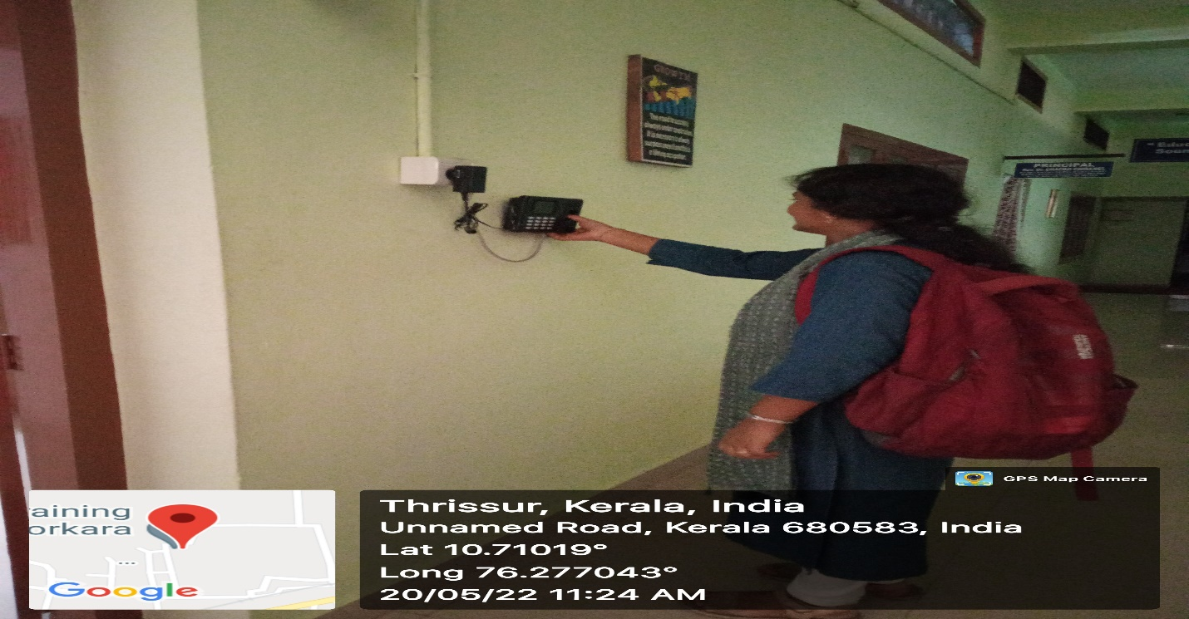
Bio-metric attendance
Landing page of E-Church software

